Exploring how climate will impact plant-insect distributions
and interactions using open data and informatics

SP-3: Future Species Distribution Models and Hypothesis Evaluation
- Assignment -

- Example -

Student Name

I. Butterfly Forecast Model: Papilio cresphontes

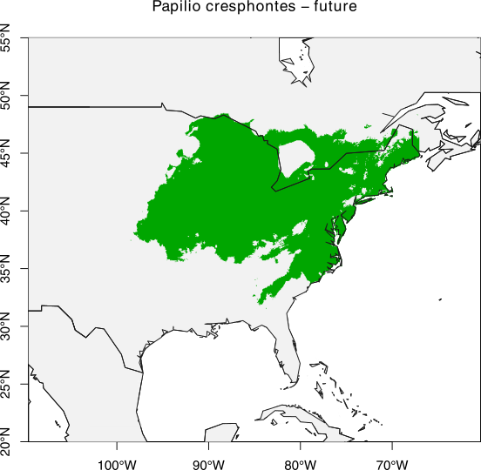
Figure 1. Species distribution model (SDM) for Papilio cresphontes for forecast (2070) climate conditions. SDM generated in R using research grade observation data collected from iNaturalist on 2018-02-01. Green area in the map represents the projected distribution of P. cresphontes.

Evaluation of model: Compared to the model for current conditions, the range of Papilio cresphontes is predicted to expand slightly to the north and contract significantly from the southern portion of its range.

II. Host Plant Forecast Model: Zanthoxylum americanum

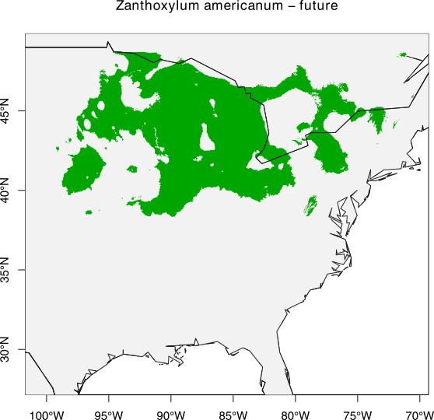
Figure 2. Species distribution model (SDM) for Zanthoxylum americanum for forecast (2070) climate conditions. SDM generated in R using research grade observation data collected from iNaturalist on 2018-02-01. Green area represents the projected current distribution of Z. americanum.

Evaluation of model: The range of Zanthoxylum americanum is predicted to expand north to reach the border of the USA and Canada and contract out of the southern plains states (Texas, Oklahoma, and Kansas).

III. Model Comparison of Forecast Distribution Overlap: Papilio cresphontes & Zanthoxylum americanum
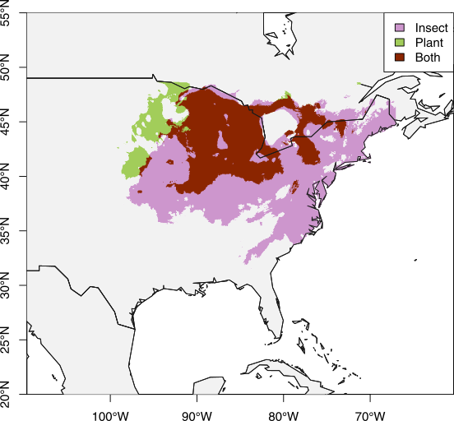
Figure 3. Species distribution models (SDMs) for Papilio cresphontes (pink), Zanthoxylum americanum (green), and area of overlap (red) for forecast (2070) climate conditions. Papilio cresphontes occupies 80.25% of the range of Z. americanum in this model. SDM generated in R.
Evaluation of the model: Compared to the present-day SDM, the percentage overlap does not change by much. However, the distribution of both the butterfly and the host-plant are predicted to contract and move northward. This means that the area of overlap between the butterfly and host-plant now occupies more of the overall range of the butterfly and host plant compared to present-day.
IV. Hypothesis for effects of climate change on this plant-insect interaction.
If the climate continues to warm, Papilio cresphontes will expand into northern Iowa and Minnesota, where its larval host plant, Zanthoxylum americanum currently exists.
V. Evaluation of Climate Change Hypothesis
Based on the comparison of the models for current and forecast climate conditions, both Papilio cresphontes and Zanthoxylum americanum are predicted to move their respective distributions northward in support of the hypothesis. Papilio cresphontes is predicted to move north into the northern Great Plains (northern Iowa and Minnesota), although not as far north and west as Z. americanum is predicted to expand. Even though increased climate temperature may allow P. cresphontes to expand its distribution northward, Z. americanum appears to be able to tolerate colder temperatures than P. cresphontes can survive in.

